Jean Hailes
Persistent Pelvic Pain
Service questionnaire
The information from these questions will help your clinician prepare for your first session.
Please note, this is not a diagnostic tool, it is simply to help your clinician.

Contact
- Name
- Address
- Date of birth / /
- Phone:
Work Home Mobile
- Referring health provider’s name and address (if applicable):

- Usual GP/health provider’s name and address (if different from referring provider):

Demographic information
- Are you:
- Single
- Married/committed relationship
- Separated
- Divorced
- Do you identify as: female, male, other (please highlight your response)
What is your current occupation?
- Please list your top 3 concerns that you would like addressed:

Information about your pain
- Please describe your pain problem (use a separate sheet of paper if needed):

- How long have you had this pain? years months
- What do you think is causing your pain?

- Is there an event that you associate with the onset of your pain?
- Yes
- No
- If so, what?

- Is your pain stable/getting worse/improving?

Pain maps
(Brief Pain Inventory)
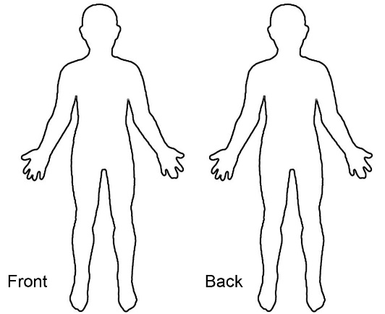
- Throughout our lives, most of us have had pain from time to time (such as minor headaches, sprains, toothaches). Today, have you had pain other than these everyday types of pain?
- Yes
- No

- On the diagram, shade in the areas where you
feel pain. Put an X on the area that hurts the most.
Or explain it in words here: _______________
___________________________________________

- Please rate your pain by highlighting one number that best describes your pain at its worst in the past
24 hours.
1 2 3 4 5 6 7 8 9 10
No pain Pain as bad as you can imagine
- Please rate your pain by highlighting one number that best describes your pain at its least in the
past 24 hours.
1 2 3 4 5 6 7 8 9 10
No pain Pain as bad as you can imagine
- Please rate your pain by highlighting one number that best describes your pain on average.
1 2 3 4 5 6 7 8 9 10
No pain Pain as bad as you can imagine
- Please rate your pain by highlighting one number that tells how much pain you have right now.
1 2 3 4 5 6 7 8 9 10
No pain Pain as bad as you can imagine
- What treatment or medication are you receiving for the pain?

- In the past 24 hours, how much relief have pain treatments or medication provided? On a scale of 1
to 10, please highlight one number that best shows how much relief you have received.
1 2 3 4 5 6 7 8 9 10
No relief Complete relief
- Highlight one number that describes how, during the past 24 hours, pain has interfered with your:
a. General activity
1 2 3 4 5 6 7 8 9 10
Does not interfere Completely interferes
b. Mood
1 2 3 4 5 6 7 8 9 10
Does not interfere Completely interferes
c. Walking ability
1 2 3 4 5 6 7 8 9 10
Does not interfere Completely interferes
d. Normal work (includes both work outside the home and housework)
1 2 3 4 5 6 7 8 9 10
Does not interfere Completely interferese.

Relations with other people
1 2 3 4 5 6 7 8 9 10
Does not interfere Completely interferes
f. Sleep
1 2 3 4 5 6 7 8 9 10
Does not interfere Completely interferes
g. Enjoyment of life
1 2 3 4 5 6 7 8 9 10
Does not interfere Completely interferes
h. Ability to concentrate
1 2 3 4 5 6 7 8 9 10
Does not interfere Completely interferes
I. Appetite
1 2 3 4 5 6 7 8 9 10
Does not interfere Completely interferes

Vulvar / perineal pain
(pain outside and around the vagina and anus)
- If you have vulvar/perineal pain, highlight the painful areas and put an X on the area that hurts the most. Or explain in words here: ______________________________________________________________________
_____________________________________________________________________________________________
- If yes, when do you get this pain?
- Anytime
- With intercourse or sexual stimulation
- Using tampons
- Sitting
- With vaginal infections
- Is your pain relieved by sitting on a toilet seat?
- Yes
- No
- How would you describe your pain? (tick all that apply)
- Sharp/stabbing
- Crampy
- Dull
- Aching
- Pulling/tugging
- Throbbing
- Burning
- Heavy/falling out sensation in pelvis
- Other
- How long do your pain episodes last? (please circle)
minutes / hours / days
- Does the pain ever spread to other parts of your body?____________________________
- Does the pain ever wake you from sleep?_________________________________________
- For each of the questions listed below, please rate your pain out of 10, with 0 being no pain and 10 being the worst pain imaginable
___Pain at ovulation (mid-cycle)
___Pain just before period
___Pain during period
___Pain after period is finished
___Pain with intercourse
___Pain lasting hours or days after intercourse
___Pain in groin when lifting
___Pain when bladder is full
___Pain with urination
___Pain with bowel actions
___Pain with exercise—please list which exercise(s) cause your pain:
__________________________________________________________
__________________________________________________________
___Muscle/joint pain
___Backache
___Migraine headache
___Pain with sitting
- Is there anything that makes your pain worse?______________________________
- Is there anything that makes your pain better?________________________________
- How many days a month would you have no pain?__________
- Do you miss school or work due to your pain?
- Yes
- No
- If yes, how many days a month?_________
- What types of treatments have you tried in the past for your pain? (tick all that apply)
- Nutrition/diet
- Meditation/mindfulness
- Acupuncture
- Herbal remedies – please list:
____________________________________________________________
____________________________________________________________
- Hormonal medication (including contraceptive pill/ring, Implanon NXT, Mirena IUD) — please list:
____________________________________________________________
____________________________________________________________
- Other medication (prescription and non-prescription) — please list
____________________________________________________________
____________________________________________________________
- Surgery
- Counselling/psychotherapy
- Botox injections to the pelvic floor
- Nerve blocks
- TENS
- Pelvic floor muscle strengthening or relaxing exercises
- Massage
- Other (please list)
_____________________________________________________________
- Which health providers have you seen in the past for your pain? (tick all that apply)
- General practitioner/primary healthcare provider
- Gynaecologist
- Urologist
- Gastroenterologist
- Surgeon
- Psychologist
- Psychiatrist
- Naturopath
- Acupuncturist
- Pain physician
- Physiotherapist
- Chiropractor
- What treatments or providers have been helpful so far?
____________________________________________________________
____________________________________________________________
- Please list all your current medications, including non-prescription and supplements
____________________________________________________________
____________________________________________________________
____________________________________________________________

- Do you have any allergies?
____________________________________________________________
____________________________________________________________
- Do you use any form of contraception?
____________________________________________________________
____________________________________________________________

Menstrual history
- How old were you when your menstrual periods started?
___ years
- Are you still having menstrual periods?
- Yes
- No

Answer the following (questions 46-50) only if you are still having menstrual periods
- Periods are:
- Light
- Moderate
- Heavy
- Bleed through protection
- Do you pass clots in menstrual flow?
- Yes
- No
- How many days between the first day of a period and the first day of the next period (cycle length)? ____________________
- How many days of menstrual flow? ____________________
- Date of first day of last menstrual period? ____________________

Surgical and medical history
- Please list all surgical procedures you have had related to this pain:
_______________________________________________________________________________________
_______________________________________________________________________________________ _______________________________________________________________________________________
- Please list all other surgical procedures:
________________________________________________________________________________________
________________________________________________________________________________________
________________________________________________________________________________________
- Do you have any medical or other health problems (including mental health)?
________________________________________________________________________________________
________________________________________________________________________________________
________________________________________________________________________________________
- Have you had any pregnancies?
- Yes
- No
- What were the outcomes of your pregnancies? (normal birth/vacuum delivery/forceps delivery/caesarean section/miscarriage/termination)
________________________________________________________________________________________
________________________________________________________________________________________
________________________________________________________________________________________

Family history
- Has anyone in your family had (tick all that apply):
- Endometriosis
- Chronic pain conditions including pelvic pain, fibromyalgia, migraine
- Depression/anxiety
- Other mental health concerns
- Inflammatory bowel disease
- Blood clots in the legs or the lungs
- Cancer — please specify type______________________________________

Gastrointestinal history
- How would you describe your diet?
________________________________________________________________________________________
________________________________________________________________________________________
_______________________________________________________________________________________
- Do you have any of the following gastrointestinal (gut) symptoms? (tick all that apply)
- Nausea/vomiting
- Diarrhoea
- Abdominal pain
- Bloating
- Constipation
- Reflux/heartburn
- Increased pain with bowel movements
- Rectal bleeding or blood in your bowel movement
- Do you have pain or discomfort that is associated with any of the following?
- Change in frequency of bowel movement
- Change in appearance of bowel movement
- Change in pain after completing a bowel movement
- Different bowel movements
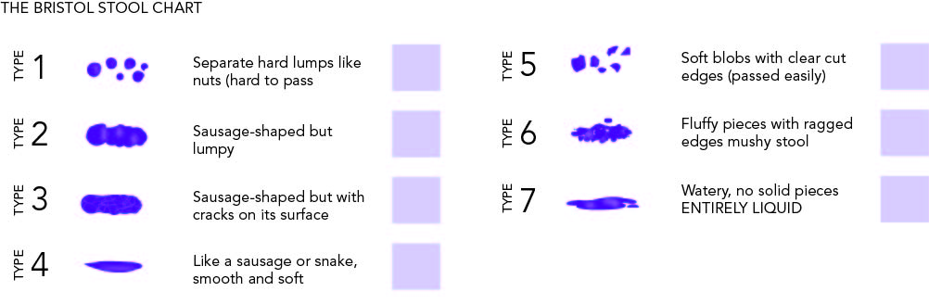

Genito-urinary history
- Do you have any concerns about your bladder function?
- Yes
- No
- Sometimes
- If yes/sometimes, do you experience
- Leakage of urine when you laugh/cough/sneeze/exercise
- Leakage of urine if you need to empty your bladder
- Leakage of urine at other times, eg when asleep; during sexual intercourse; without being aware of it
- Difficulty starting the urine flow
- Still feeling full after passing urine
- Pain with a full bladder
- Pain when emptying your bladder
- Frequent bladder infections
- Blood in the urine
- How many times a day do you pass urine:
During the day_______________________________
At night after going to bed_____________________
- Please list what type of fluid, and number of cups of each, that you drink each day
____________________________________________________________________________________________________________________________________________________________________________
- Have you had any pelvic infections such as chlamydia, gonorrhoea, PID?
- Yes
- No
- When was your last cervical screening test or Pap smear?___________________________________
- Do you have any concerns about your sexual health?
- Yes
- No
Please highlight as many as apply”
libido / arousal / lubrication / orgasm / discomfort

Health habits
- What type of exercise do you do?_______________________________________________________
________________________________________________________________________________________
- How often? ______________________
- What is your caffeine intake (cups per day, including coffee, tea, soft drinks)? ________________
- Do you drink alcohol?
- Yes
- No
How many drinks per day? ___________
For how many years?_______________
- Do you use any recreational drugs?
- Yes
- No
- Previously
- If yes, tick all that apply
- Marijuana/cannabis
- Amphetamines
- Psychedelics
- Cocaine
- Opiates including morphine/pethidine/heroin
- Other ____________________________________
- Do you use any of these for pain control?
- Yes
- No

- How would you rate your sleep?
- Good
- Poor
- How would you rate your energy levels?
- Good
- Moderate
- Poor
- How would you rate your stress levels?
- Low
- Medium
- High
- Do you have any strategies to manage your stress?
________________________________________________________________________________________
________________________________________________________________________________________
- Compared to other sources of stress in your life, how does your pain compare in importance?
- The most important problem
- One of many problems

Psychosocial history
- Who are the people that you talk to concerning your pain? (highlight all that apply)
- Spouse/partner
- Relative
- Friend
- Support group (in person or online)
- Health professional
- Other
- I take care of myself
- If you have a partner, how do they respond to your pain?
- Takes care of me, is supportive
- Distracts me with activities
- Gets angry or withdraws from me
- Feels helpless
- Doesn’t notice if I’m in pain

- Do you believe that your pain impacts other areas of your life? (highlight all that apply)
- Family
- Children
- Friends
- Work/education
- Recreational activities
- Intimacy
- Are there relationships you think may be contributing to your symptoms?
- Yes
- No

The next questions are about trauma or abuse that you may have experienced or be experiencing. Please answer these if you feel comfortable to do so, or advise us if you would prefer to answer in person.
- Have you experienced trauma or abuse before 13 years of age?
- Yes
- No
If yes, please highlight any that apply
- Emotional/psychological
- Physical
- Sexual
- Domestic violence
- Were you supported with professional or other assistance at that time, or have been since that time?
- Yes
- No
- Have you experienced trauma or abuse as a teenager or an adult?
- Yes
- No
If yes, please highlight any that apply
- Emotional/psychological
- Physical
- Sexual
- Domestic violence

- Were you supported with professional or other assistance at that time, or have been since that time?
- Yes
- No
- Are you currently experiencing any forms of abuse?
- Yes
- No
- Are you currently safe?
- Yes
- No
- Are any services or other professional/ personal supports currently involved with you in this regard?
- Yes
- No
- Would you like further information about how to access professional assistance regarding trauma or abuse?
- Yes
- No

Pain Catastrophizing Scale
Everyone experiences painful situations at some point in their lives. Such experiences may include headaches, tooth pain, joint or muscle pain. People are often exposed to situations that may cause pain such as illness, injury, dental procedures or surgery.
We are interested in the types of thoughts and feelings that you have when you are in pain. Listed below are 13 statements describing different thoughts and feelings that may be associated with pain. Using the scale, please indicate the degree to which you have these thoughts and feelings when you are experiencing pain.
 | Not at all | To a slight  degree | To a  moderate  degree | To a great  degree | All the  time
I worry all the time about whether the pain will end | 0 | 1 | 2 | 3 | 4
I feel I can't go on | 0 | 1 | 2 | 3 | 4
It's terrible and I think it's never going to get any better | 0 | 1 | 2 | 3 | 4
It's awful and I feel that it overwhelms me | 0 | 1 | 2 | 3 | 4
I feel I can't stand it anymore | 0 | 1 | 2 | 3 | 4
I'm afraid that the pain will get worse | 0 | 1 | 2 | 3 | 4
I keep thinking of other painful events | 0 | 1 | 2 | 3 | 4
I anxiously want the pain to go away | 0 | 1 | 2 | 3 | 4
I can't seem to keep it out of my mind | 0 | 1 | 2 | 3 | 4
I keep thinking about how much it hurts | 0 | 1 | 2 | 3 | 4
I keep thinking about how badly I want the pain to stop | 0 | 1 | 2 | 3 | 4
There's nothing I can do to reduce the intensity of the pain | 0 | 1 | 2 | 3 | 4
I wonder whether something serious might happen | 0 | 1 | 2 | 3 | 4

Thank you very much for taking the time to answer these questions. They will be kept in confidence and only used to help better understand and manage your condition.

